IMPORT USING COMMAND IN SQL

**Steps**

Step1: Place CSV files /Users/el/Desktop/dbfiles/Final/CSV_FILES/ (Since we are using MACBOOK we don’t have c:\ folder. We have placed the files in desktop. Choose any location you want).

Step2: Create a table using create statements.

Step3: Load data using command: -

LOAD DATA LOCAL INFILE '/Users/el/Desktop/dbfiles/Final/CSV_FILES/TEAM.csv'

INTO TABLE TEAM

FIELDS TERMINATED BY ','

ENCLOSED BY '"'

LINES TERMINATED BY '\n'

IGNORE 1 ROWS;

Screenshots: -

Create database: -

create database DB1_TEST;

USE DB1_TEST;

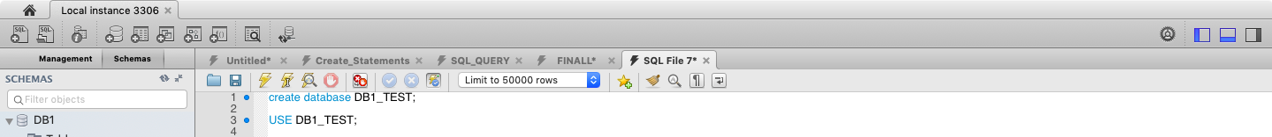

Create table TEAM

CREATE TABLE TEAM (

TeamID varchar(25) NOT NULL,

Team varchar(15) ,

Continent varchar(15),

League varchar(15) ,

Population bigint ,

PRIMARY KEY (TeamID),

UNIQUE KEY (Team)

) ;

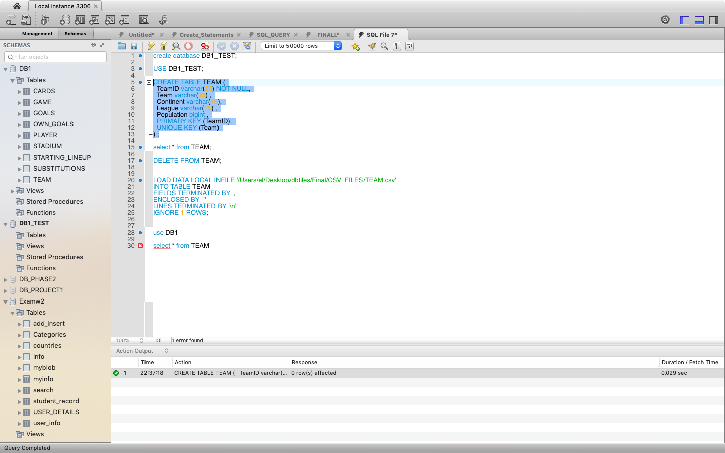

LOAD DATA LOCAL INFILE '/Users/el/Desktop/dbfiles/Final/CSV_FILES/TEAM.csv'

INTO TABLE TEAM

FIELDS TERMINATED BY ','

ENCLOSED BY '"'

LINES TERMINATED BY '\n'

IGNORE 1 ROWS;

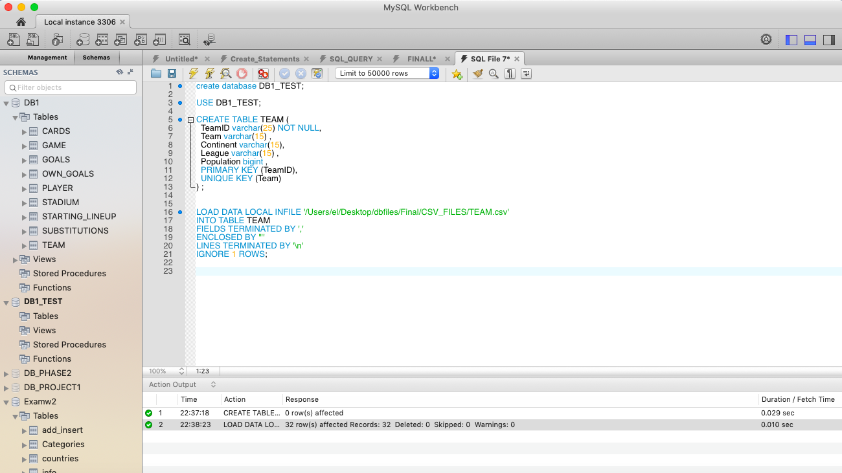

Create table STADIUM

CREATE TABLE STADIUM (

SID varchar(25) NOT NULL,

SName varchar(255) ,

SCity varchar(255) ,

SCapacity int,

PRIMARY KEY (SID),

UNIQUE KEY (SName)

) ;

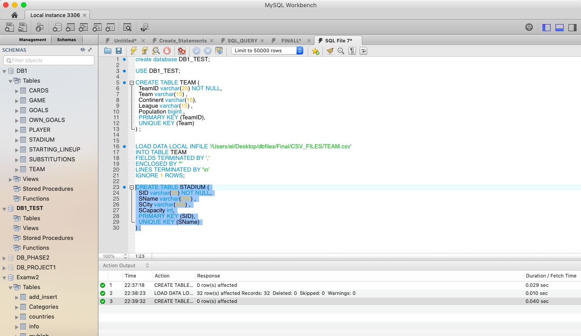

LOAD DATA LOCAL INFILE '/Users/el/Desktop/dbfiles/Final/CSV_FILES/STADIUM.csv'

INTO TABLE STADIUM

FIELDS TERMINATED BY ','

ENCLOSED BY '"'

LINES TERMINATED BY '\n'

IGNORE 1 ROWS;

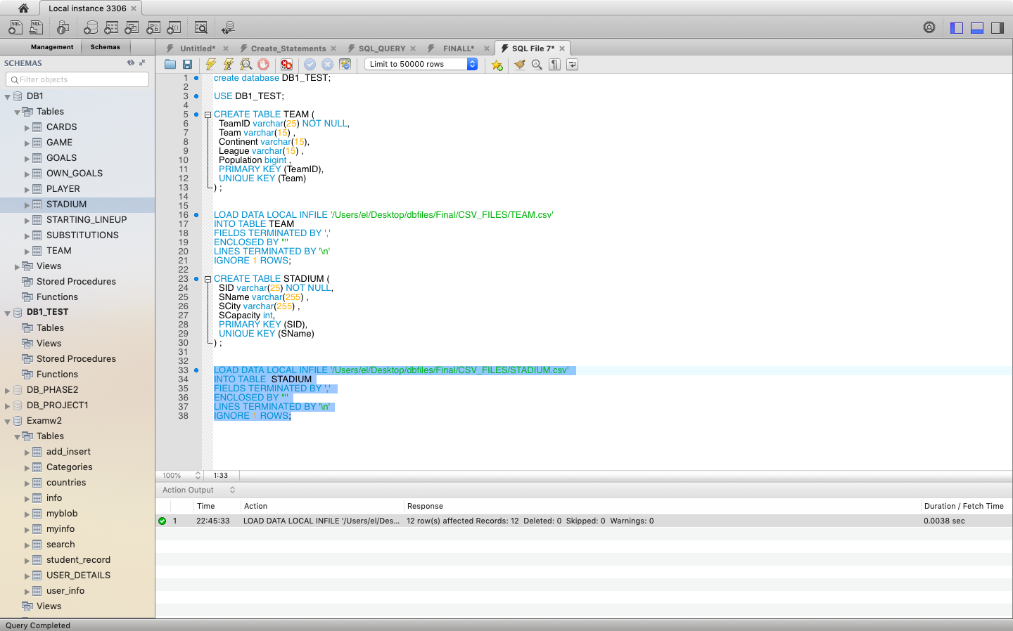

Create table PLAYER

CREATE TABLE PLAYER (

Team varchar(15) NOT NULL,

TeamID varchar(25) NOT NULL,

PNo int NOT NULL,

P_Position char(5) ,

Pname varchar(50) ,

BD varchar(200) ,

Shirt_Name varchar(255),

Club varchar(255) ,

Height int,

Weight int,

PRIMARY KEY (TeamID,PNo),

CONSTRAINT `player2` FOREIGN KEY (TeamID) REFERENCES TEAM (TeamID)

) ;

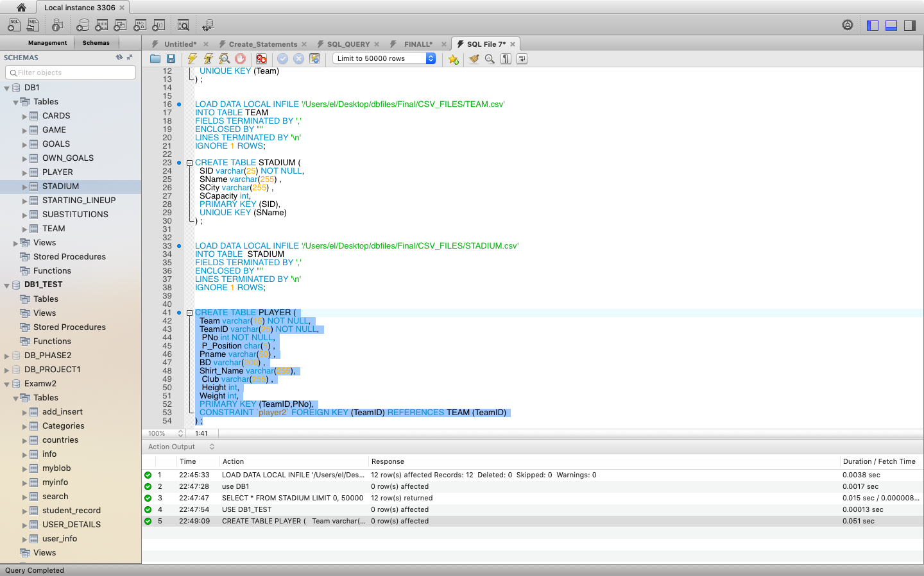

LOAD DATA LOCAL INFILE '/Users/el/Desktop/dbfiles/Final/CSV_FILES/PLAYER.csv'

INTO TABLE PLAYER

FIELDS TERMINATED BY ','

ENCLOSED BY '"'

LINES TERMINATED BY '\n'

IGNORE 1 ROWS;

Create table GAME

CREATE TABLE GAME (

GameID VARCHAR(25) NOT NULL,

Match_Type CHAR(10),

Match_date varchar(20),

SID varchar(25) ,

TeamID_1 varchar(25) NOT NULL ,

TeamID_2 varchar(25) NOT NULL,

Team1_Score INT,

Team2_Score INT,

PRIMARY KEY (GameID),

CONSTRAINT `game_1` FOREIGN KEY (SID) REFERENCES STADIUM (SID),

CONSTRAINT `game_2` FOREIGN KEY (TeamID_1) REFERENCES TEAM (TeamID),

CONSTRAINT `game_3` FOREIGN KEY (TeamID_2) REFERENCES TEAM (TeamID)

) ;

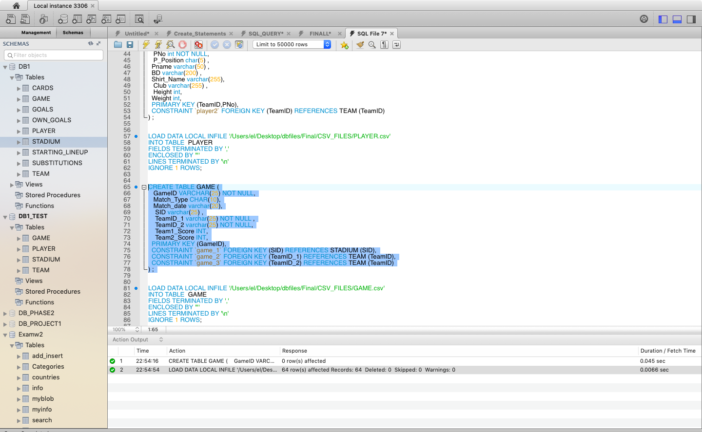

LOAD DATA LOCAL INFILE '/Users/el/Desktop/dbfiles/Final/CSV_FILES/GAME.csv'

INTO TABLE GAME

FIELDS TERMINATED BY ','

ENCLOSED BY '"'

LINES TERMINATED BY '\n'

IGNORE 1 ROWS;

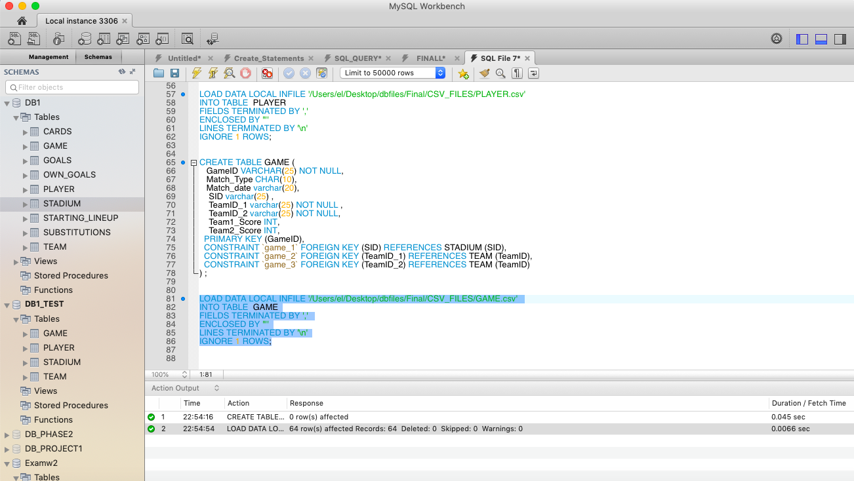

Create table STARTING_LINEUP

CREATE TABLE STARTING_LINEUP (

GameID VARCHAR(25) NOT NULL,

TeamID VARCHAR(25) NOT NULL,

PNo int NOT NULL,

PRIMARY KEY (GameID,TeamID,PNo),

FOREIGN KEY (GameID) REFERENCES GAME(GameID),

FOREIGN KEY (TeamID,PNo) REFERENCES PLAYER(TeamID,PNo)

)

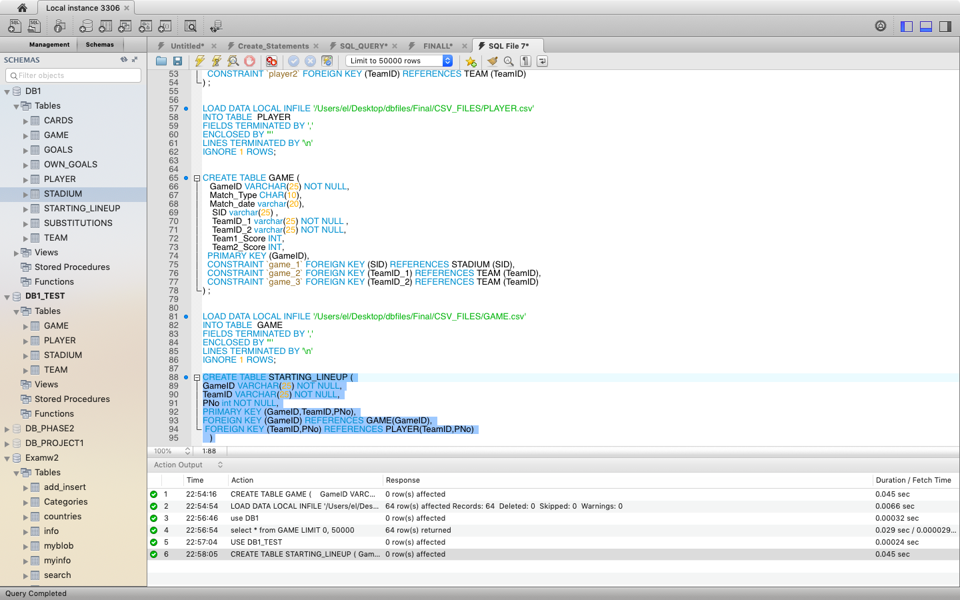

LOAD DATA LOCAL INFILE '/Users/el/Desktop/dbfiles/Final/CSV_FILES/STARTING_LINEUP.csv'

INTO TABLE STARTING_LINEUP

FIELDS TERMINATED BY ','

ENCLOSED BY '"'

LINES TERMINATED BY '\n'

IGNORE 1 ROWS;

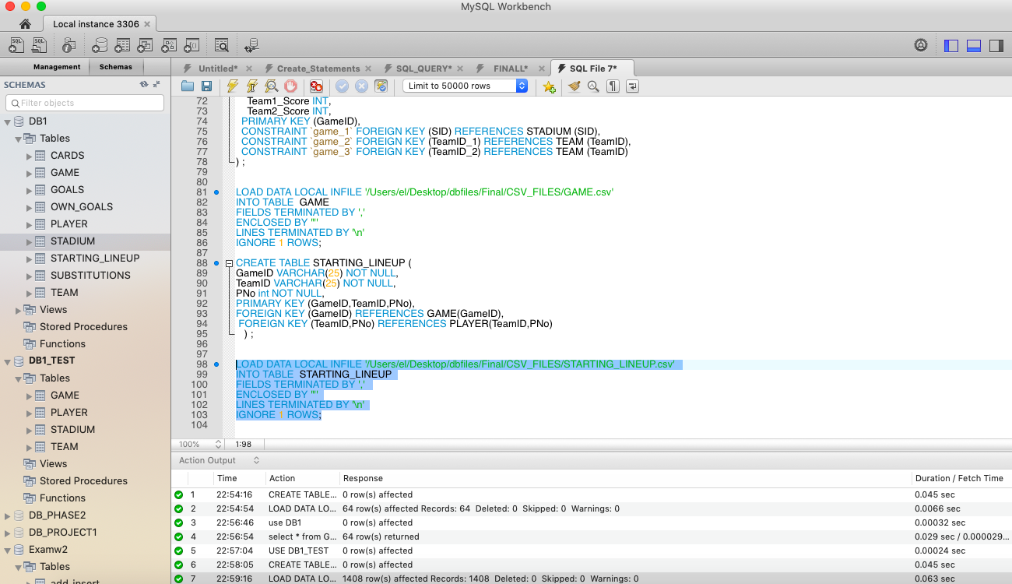

Create table SUBSTITUTIONS

CREATE TABLE SUBSTITUTIONS (

GameID VARCHAR(25) NOT NULL,

TeamID VARCHAR(25) NOT NULL,

PNoIn int NOT NULL,

P_Position char(5) ,

PNOut int NOT NULL,

sub_Time int NOT NULL,

primary key (GameID,TeamID,PNoIn),

CONSTRAINT `substituion_ibfk_1` FOREIGN KEY (GameID) REFERENCES GAME (GameID),

CONSTRAINT `substituion_ibfk_2` FOREIGN KEY (TeamID,PNoIn) REFERENCES PLAYER(TeamID,PNo),

CONSTRAINT `substituion_ibfk_3` FOREIGN KEY (TeamID,PNOut) REFERENCES PLAYER (TeamID,PNo)/* IMPORTANT*/

) ;

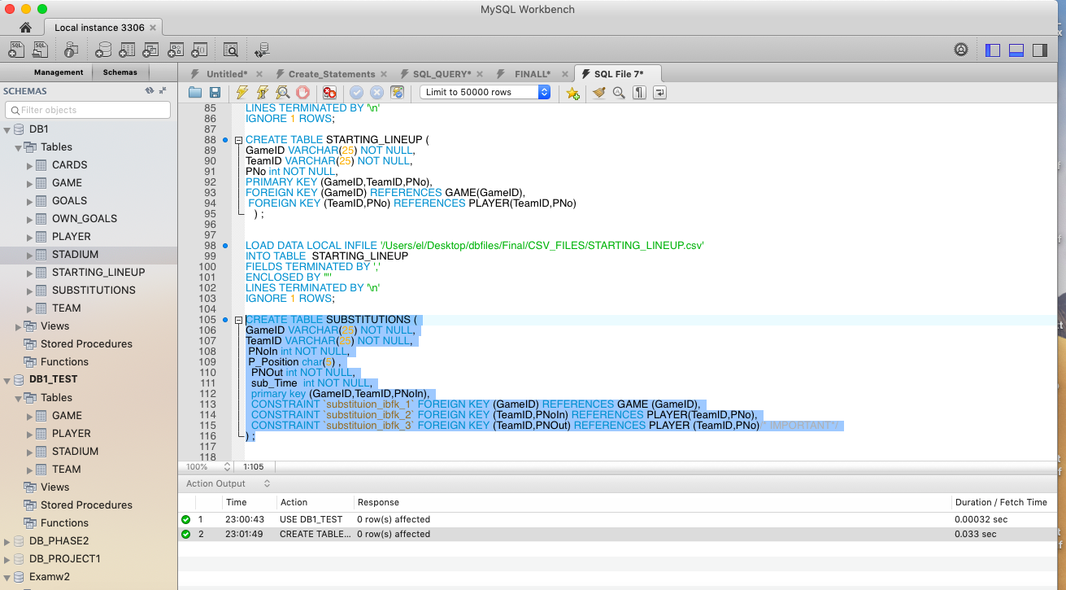

LOAD DATA LOCAL INFILE '/Users/el/Desktop/dbfiles/Final/CSV_FILES/SUBSTITUTIONS.csv'

INTO TABLE SUBSTITUTIONS

FIELDS TERMINATED BY ','

ENCLOSED BY '"'

LINES TERMINATED BY '\n'

IGNORE 1 ROWS;

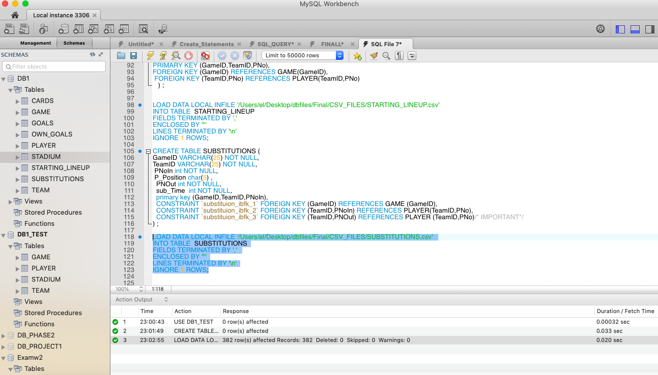

Create table GOALS

CREATE TABLE GOALS (

GameID VARCHAR(25) NOT NULL,

TeamID VARCHAR(25) NOT NULL,

PNo int NOT NULL,

G_Time char(5) ,

Penalty CHAR(5),

primary key (GameID,TeamID,PNo,G_Time),

CONSTRAINT `GOALS_ibfk_1` FOREIGN KEY (GameID) REFERENCES `GAME` (GameID),

CONSTRAINT `GOALS_ibfk_2` FOREIGN KEY (TeamID,PNo) REFERENCES PLAYER(TeamID,PNo)

) ;

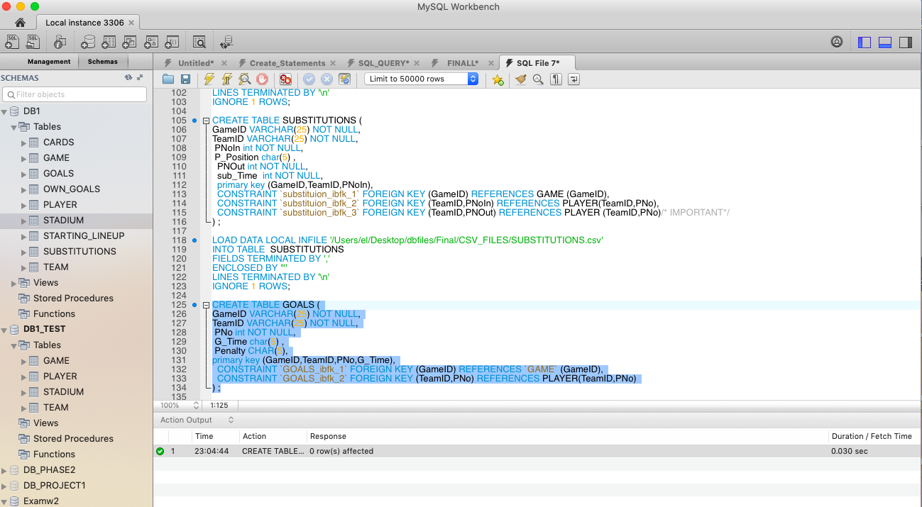

LOAD DATA LOCAL INFILE '/Users/el/Desktop/dbfiles/Final/CSV_FILES/GOALS.csv'

INTO TABLE GOALS

FIELDS TERMINATED BY ','

ENCLOSED BY '"'

LINES TERMINATED BY '\n'

IGNORE 1 ROWS;

Create table GOALS

CREATE TABLE OWN_GOALS (

GameID VARCHAR(25) NOT NULL,

TeamID VARCHAR(25) NOT NULL,

PNo int NOT NULL,

OG_Time char(5) ,

For_TeamID char(5),

primary key (GameID,TeamID,PNo,OG_Time),

CONSTRAINT `own_GOALS_ibfk_1` FOREIGN KEY (GameID) REFERENCES GAME (GameID),

CONSTRAINT `own_GOALS_ibfk_2` FOREIGN KEY (TeamID,PNo) REFERENCES PLAYER(TeamID,PNo),

CONSTRAINT `own_GOALS_ibfk_3` FOREIGN KEY (For_TeamID,PNo) REFERENCES PLAYER (TeamID,PNo)

) ;

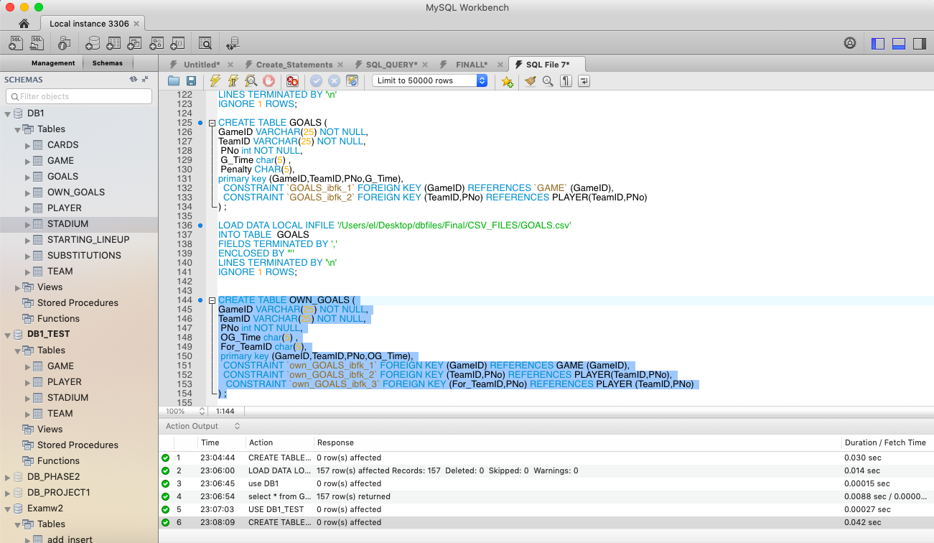

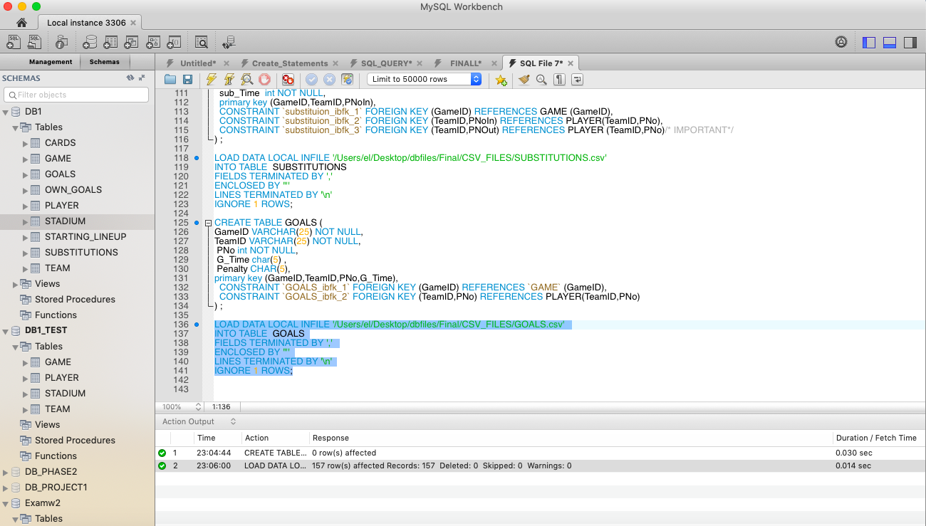

Create table OWN_GOALS

Note: OWN_GOALS data load dint work if I had included For_TeamID as a foreign key to the team. It loaded data only when we removed the foreign key constraint

CREATE TABLE OWN_GOALS (

GameID VARCHAR(25) NOT NULL,

TeamID VARCHAR(25) NOT NULL,

PNo int NOT NULL,

OG_Time char(5) ,

For_TeamID char(5),

primary key (GameID,TeamID,PNo,OG_Time),

FOREIGN KEY (GameID) REFERENCES GAME (GameID),

FOREIGN KEY (TeamID,PNo) REFERENCES PLAYER(TeamID,PNo)

/*FOREIGN KEY (For_TeamID) REFERENCES PLAYER (TeamID)*/

) ;

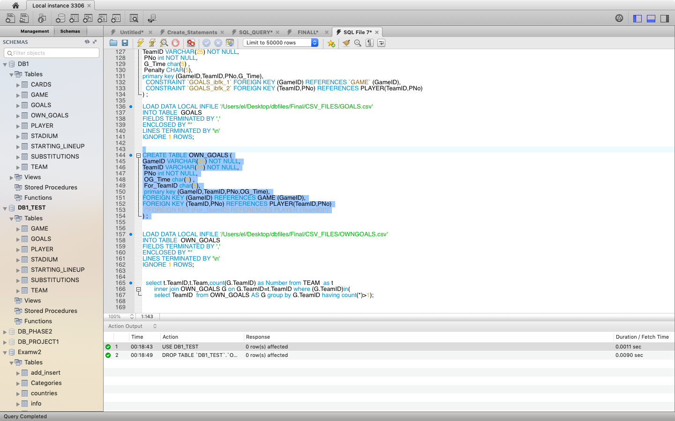

LOAD DATA LOCAL INFILE '/Users/el/Desktop/dbfiles/Final/CSV_FILES/OWNGOALS.csv'

INTO TABLE OWN_GOALS

FIELDS TERMINATED BY ','

ENCLOSED BY '"'

LINES TERMINATED BY '\n'

IGNORE 1 ROWS;

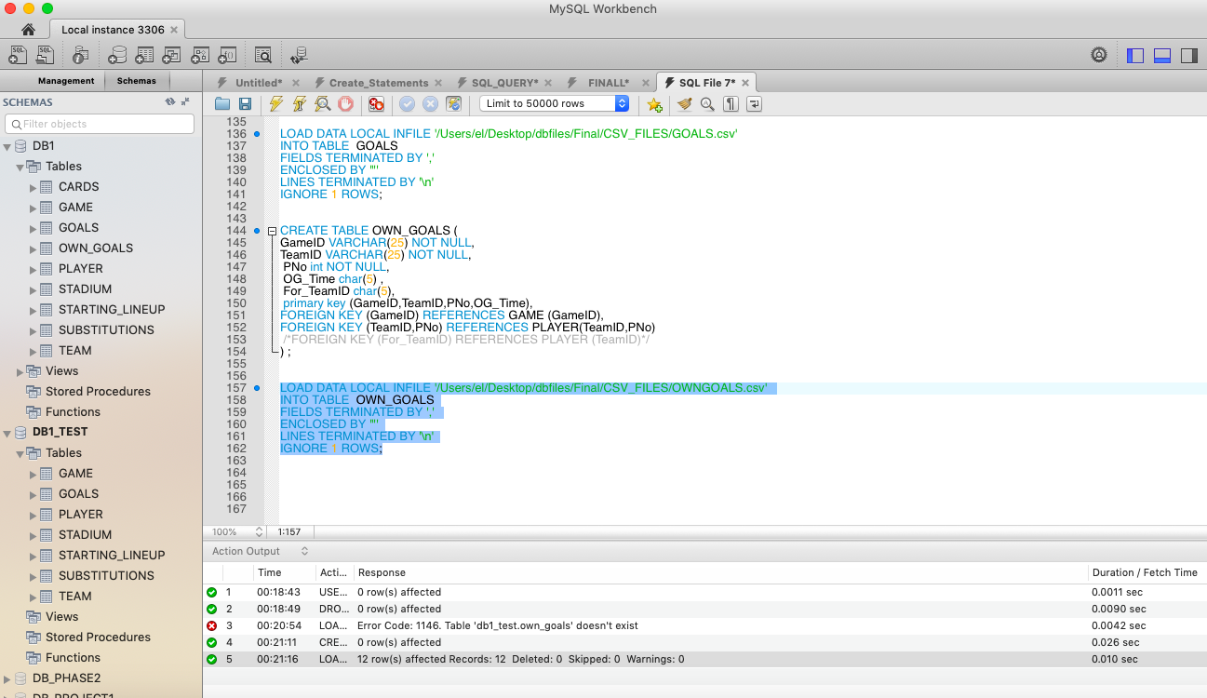

Create table CARDS

CREATE TABLE CARDS (

GameID VARCHAR(25) NOT NULL,

TeamID VARCHAR(25) NOT NULL,

PNo int NOT NULL,

Color CHAR(25),

C_Time char(5) ,

primary key (GameID,TeamID,PNo,C_Time),

CONSTRAINT `CARDS_ibfk_1` FOREIGN KEY (GameID) REFERENCES GAME (GameID),

CONSTRAINT `CARDS_ibfk_2` FOREIGN KEY (TeamID,PNo) REFERENCES PLAYER(TeamID,PNo)

) ;

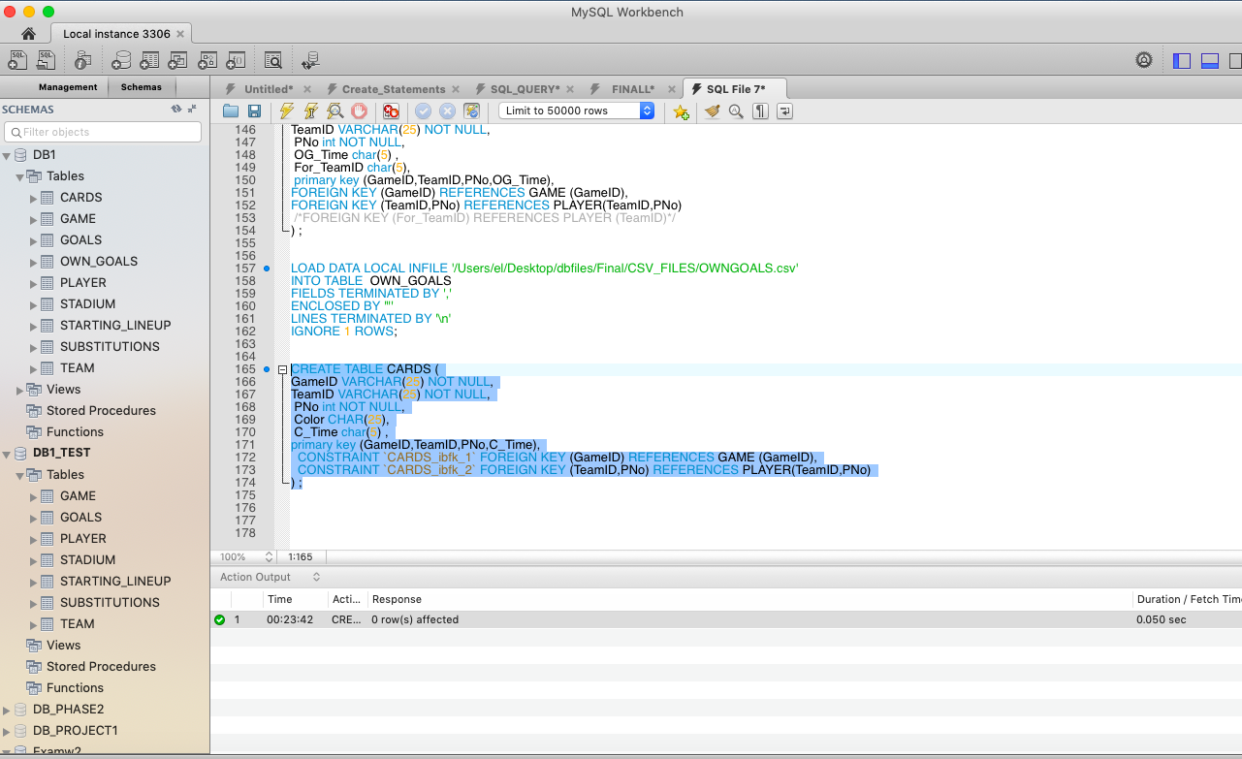

LOAD DATA LOCAL INFILE '/Users/el/Desktop/dbfiles/Final/CSV_FILES/CARDS.csv'

INTO TABLE CARDS

FIELDS TERMINATED BY ','

ENCLOSED BY '"'

LINES TERMINATED BY '\n'

IGNORE 1 ROWS;

